Comment/Response to Document in Review

Announcement Date: | September 20, 2023
Effective Date: | October 11, 2023
Notification Number: | CMPR.CTLL.09.20.23.F.20732.Wholesale_Cust_Contacts
Notification Category: | CMP; Website
Target Audience: | CLEC-Q; Resale-Q
Subject: | Wholesale Customer Contacts PCAT Updates
Disposition Level | 2

Lumen recently posted updates regarding the Wholesale Customer Contacts PCAT.
CLECs were invited to provide comments during a Document Review period from September 20, 2023 through September 27, 2023. The information listed below is Lumen’s response to CLEC comments provided during the review/comment cycle.

Document Review Site: http://www.centurylink.com/wholesale/cmp/review.html

If you have any questions on this subject or there are further details required, please contact Lumen’s Change Management Manager at cmpcomm@centurylink.com.

CenturyLink’s Response to Comments on: Wholesale Customer Contacts PCAT Updates

# | CLEC Comment | Lumen Response
1 | Zayo  September 20, 2023  Zayo objects to Lumen's deletion of the DCG contact information proposed in CMP notice CMPR.CTLL.09.20.23.F.20732.Wholesale_Cust_Contacts. In addition, Zayo noticed that Lumen has already made the change to its external Wholesale website prior to the effective date of the change and prior to the completion of the CLEC comment cycle. This is a violation of the CMP Process Documentation.  The CLECs ability to contact the DCG directly is required per the STIPULATED RESOLUTION OF CERTAIN ISSUES in Minnesota MPUC Docket No. P-421/CI-09-1066 In the Matter of a Commission Investigation into Qwest Corporation's Provision of Network Elements to CLECs and into Related Marketing Practices Targeting CLEC Customers.  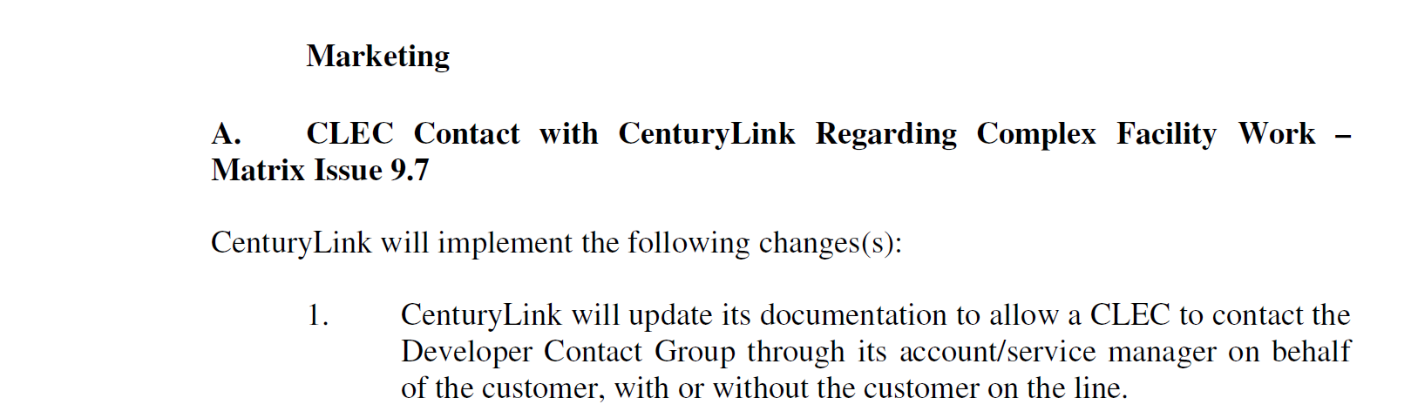  If the contact number or the method CLECs will use to reach Lumen to discuss construction on end user premises has changed, Lumen should update the Wholesale Customer Contact PCAT to reflect the new number or process.  It is Zayo's expectation that Lumen will not delete the DCG contact section without proposing new changes outlining the CLECs ability to speak directly to the Lumen engineers on behalf the end user.  Zayo would not object to the following change.  If your end-user requires extensive and complex facility rearrangement/relocation/replacement related to construction, demolition, planning and placement of conduit and Network Interface Device (NID), right-of-way, or other situations that will require engineering and special construction, the CLEC should contact their Service Manager. CLECs may contact the Lumen engineer on behalf of an end user customer (with or without the customer on the line) but must contact their Service Manager first and then the Service Manager may conference the engineer in for consultation on the end user's project. | September 26, 2023  The external Wholesale website has been changed back to the original doc and will not be changed until the effective date.  In response to Zayo objection of the deletion of the DCG contact information, Lumen has removed those redlines pending further review and will not make any changes at this time.
  For Assistance with: | Who to Contact
  CLECs needing to request consultation with a CenturyLink engineer | Service Manager

